**Week one:**

* 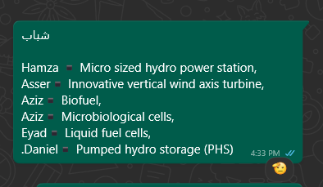Distributed the tasks among the team members and was responsible for researching two ideas
* Collected and read many research papers about the topic   
  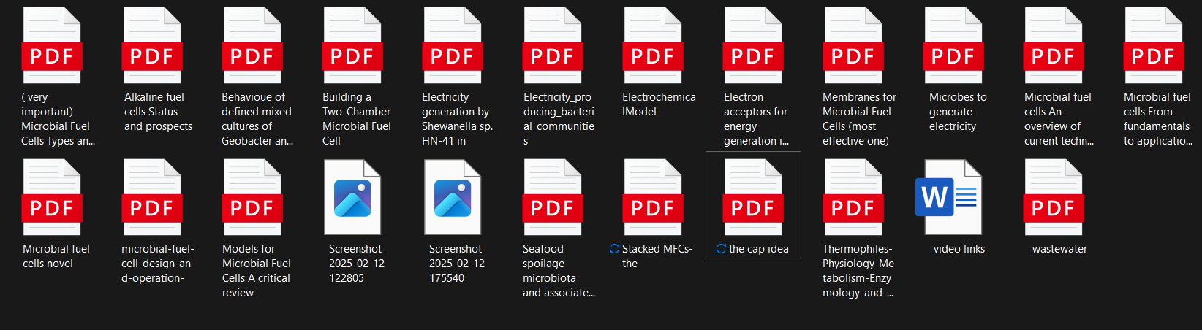
* Wrote the proposal of the stacked MFC cell design (which was rejected) 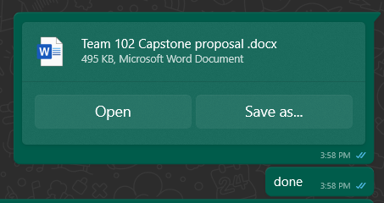
* Distributed the Grand challenges
* Once the idea was rejected, started to research others 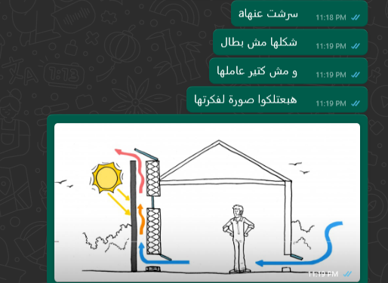

**Week Two:**

* I started writing the grands along with researching the ideas.
* I found a VAWT design named Harmony which no one took it at the time <https://harmonyturbines.com/>
* Started researching about it more and figured out that it has very complex construction, especially the part where the blades close itself
* Discovered the Lenz turbine, a type which merges VAWTs advantages together, and collected research papers about it A screenshot of a computer

  AI-generated content may be incorrect.
* Wrote the problem to be solved, 3 positive and 3 negative consequences, the grand challenge and the intro of the portfolio, which I uploaded to the team’s drive A screenshot of a computer

  AI-generated content may be incorrect.

Week three:

* Wrote the Lenz VAWT proposal 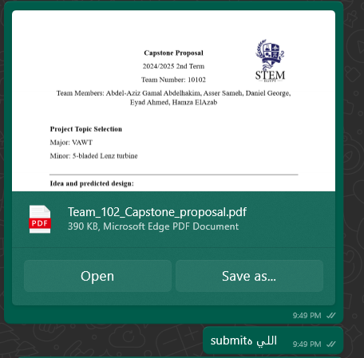
* Searched for more about the scientific base of the turbine, along with the forces that can be used to optimize it
* Distributed chapter 2 among the team (in person)
* Started writing in chapter 2 while revising chapter 1 partsA screenshot of a computer

  AI-generated content may be incorrect.

Week four:

* Found a playlist that explained the aerodynamics as a scientific concept A screenshot of a video file

  AI-generated content may be incorrect.
* Started studying the scientific base more heavily and fished the presentation of the panel review content wiseA screenshot of a computer

  AI-generated content may be incorrect.
* Revised some parts of the previous chapters

Week 5:

* Diagram of a diagram of a body

  AI-generated content may be incorrect. Dived more into the aerodynamics of aeroplanes, and enhanced the design, based on this book
* 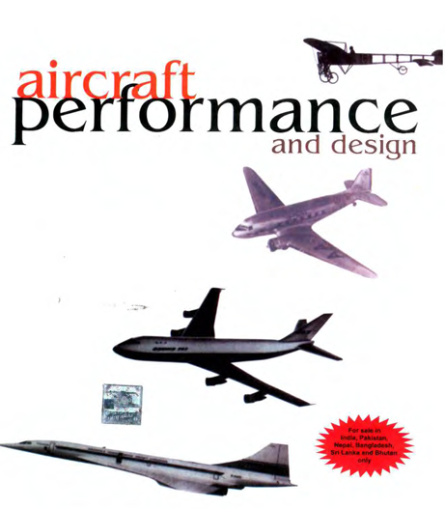Made some enhancements to the panel review
* A wooden stick with a star shape on the ground

  AI-generated content may be incorrect.Decided the prototype design measurements

Week 6:

* We all have started to search for the generator
* A type of generator called the permanent magnet generator was found.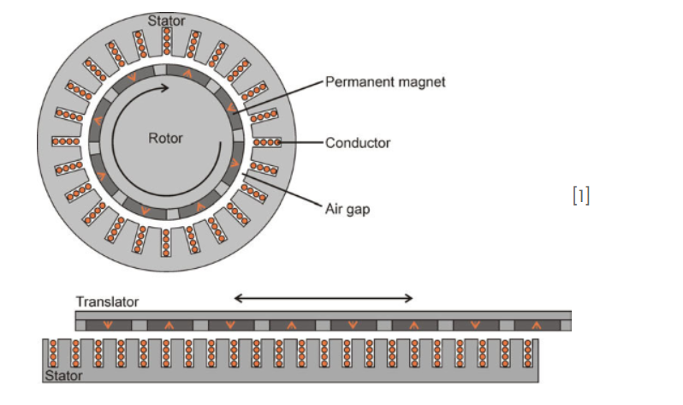
* Further understanding of the generator will be needed.